**CUSTOM BOOTCAMP**

**Azure Storage Types**

**CREATING LRS (Locally Redundant Storage Account)**

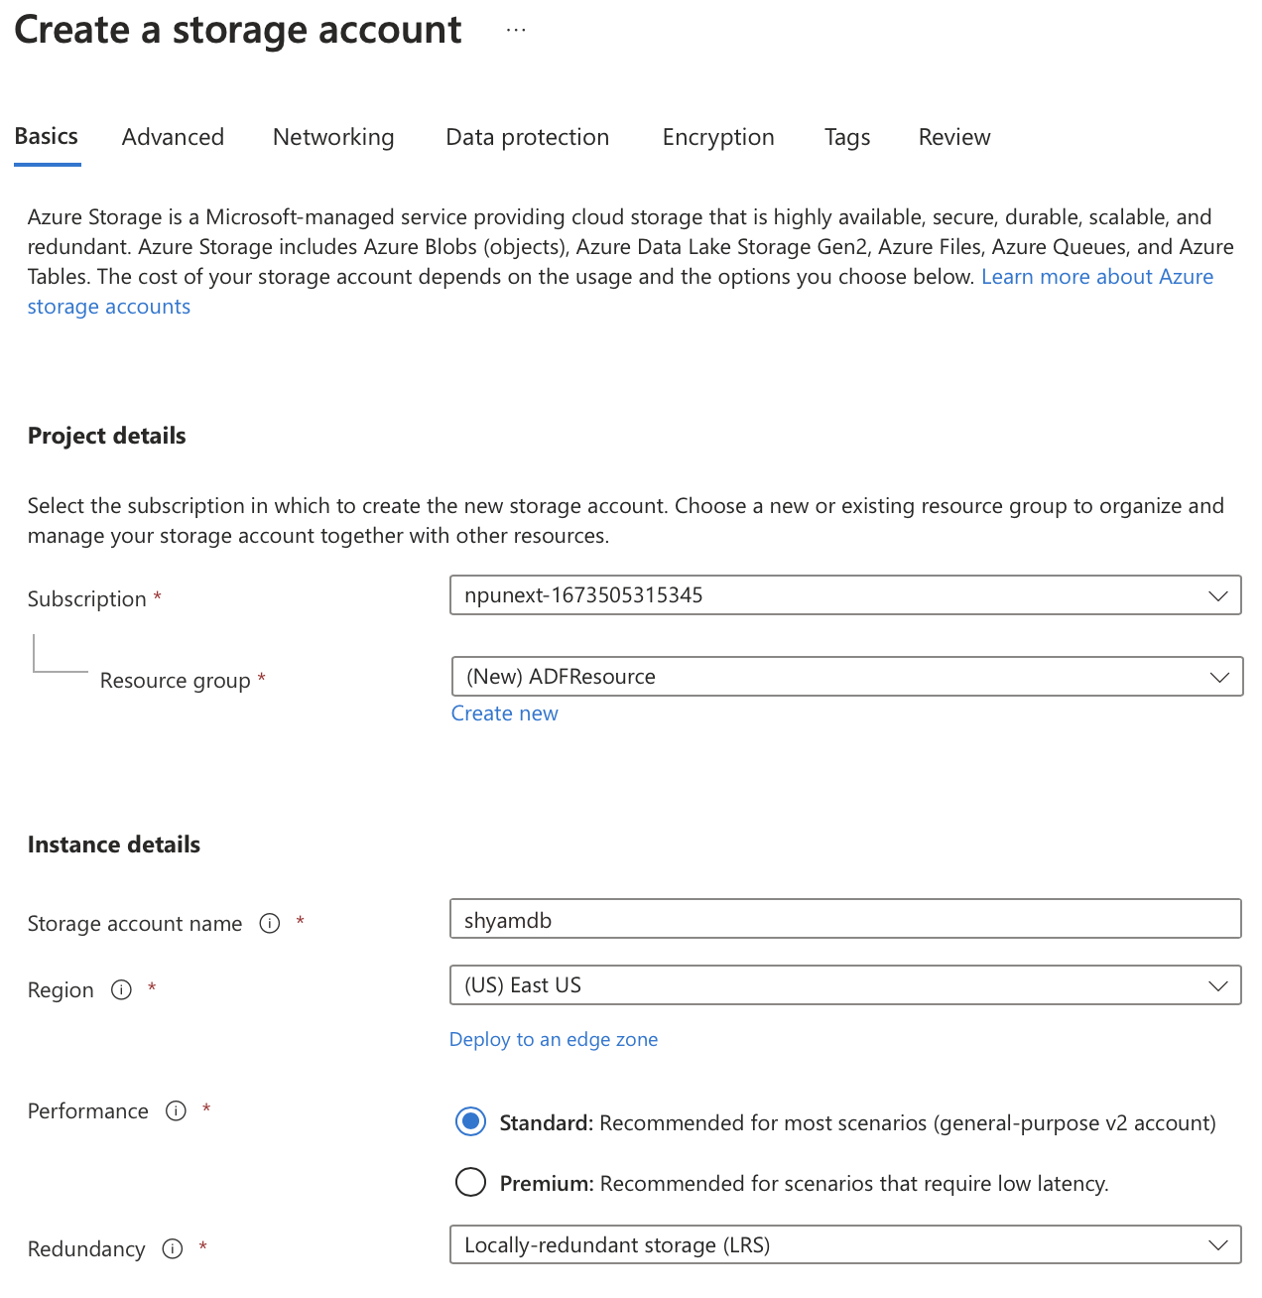

**CREATING ZRS (Zone-redundant Storage Account)**

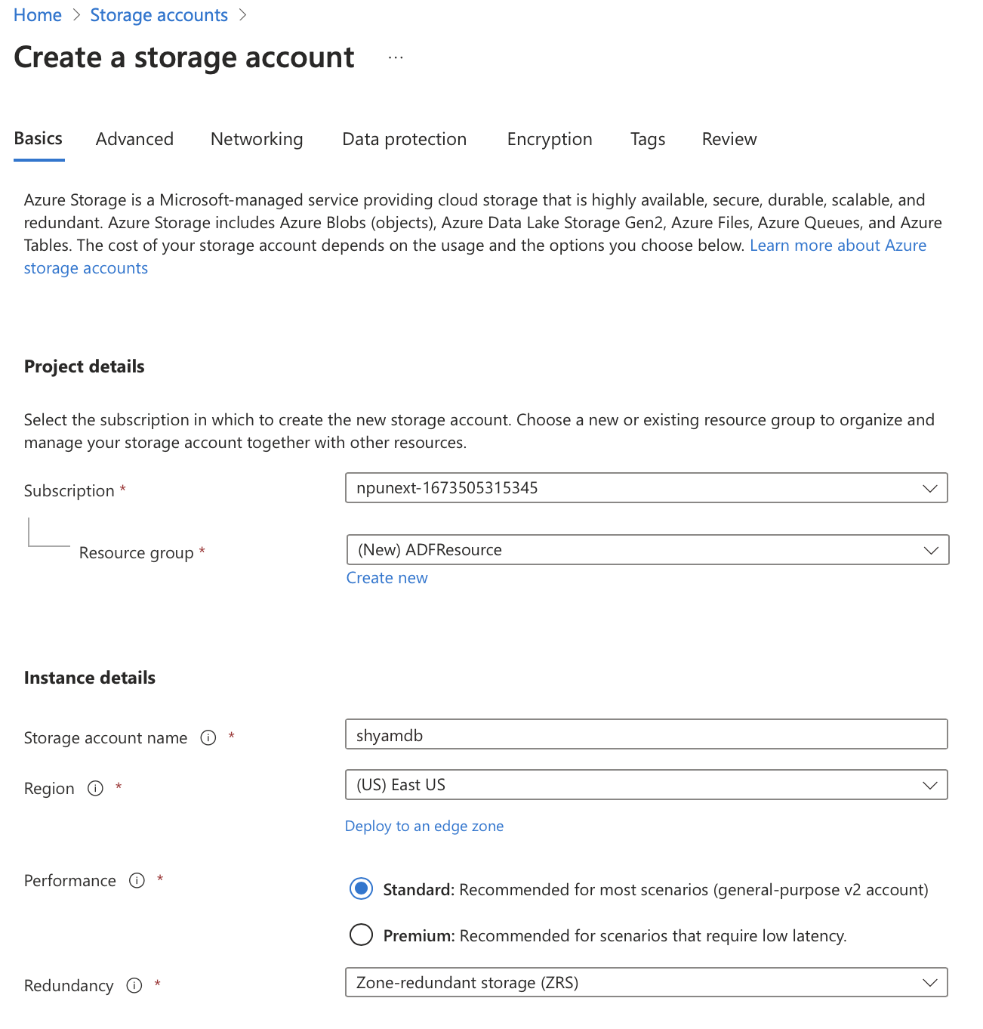

**CREATING GZRS (Geo-Zone Redundant Storage)**

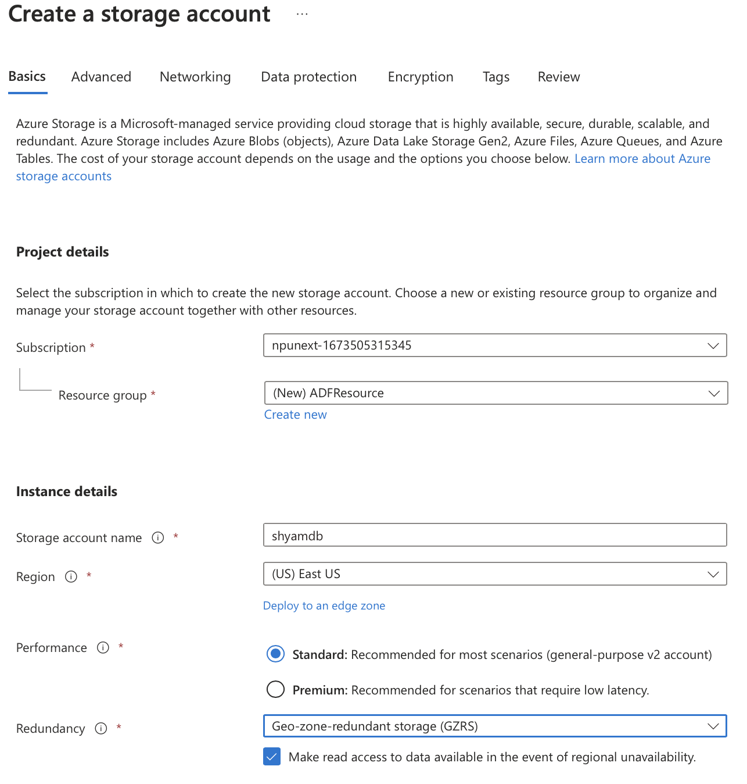

**CREATING GRS (Geo Redundant Storage)**

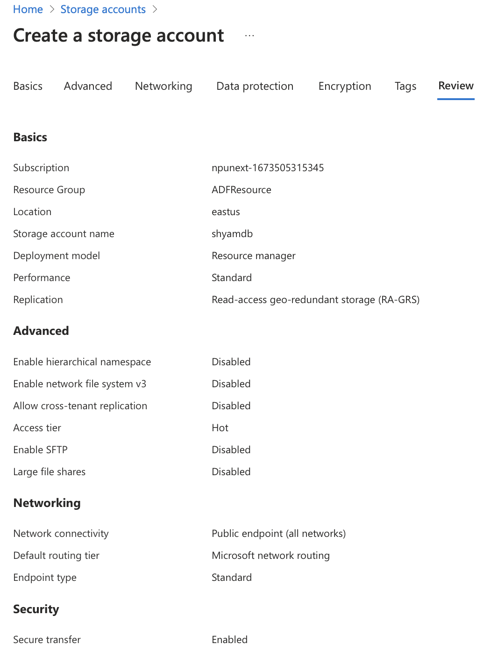

**CREATING CONTAINER**

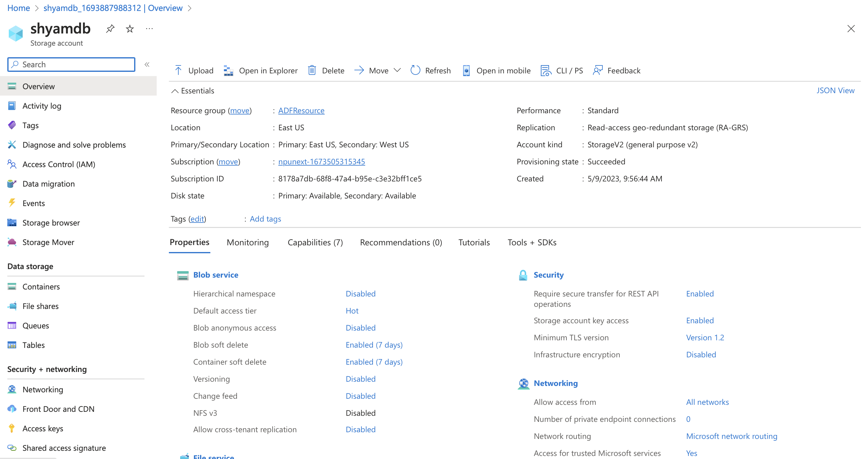

**UPLOADING FILES IN A CONTAINER**

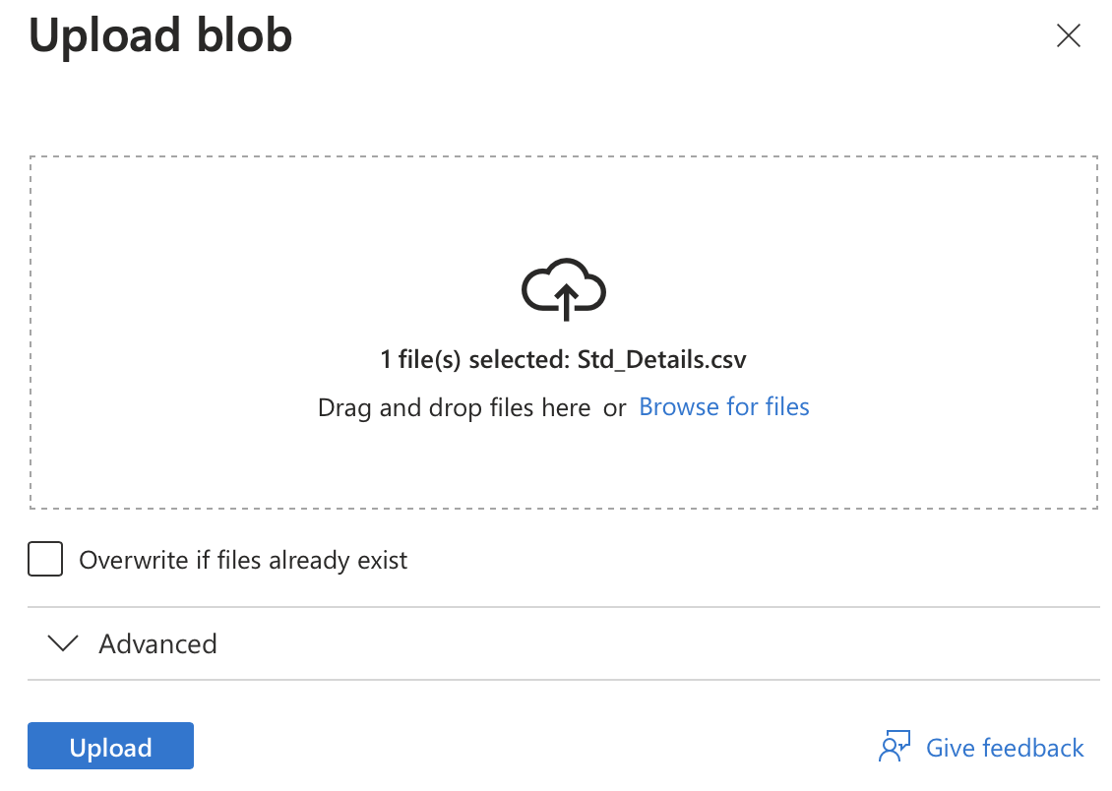

**SNAPSHOT**

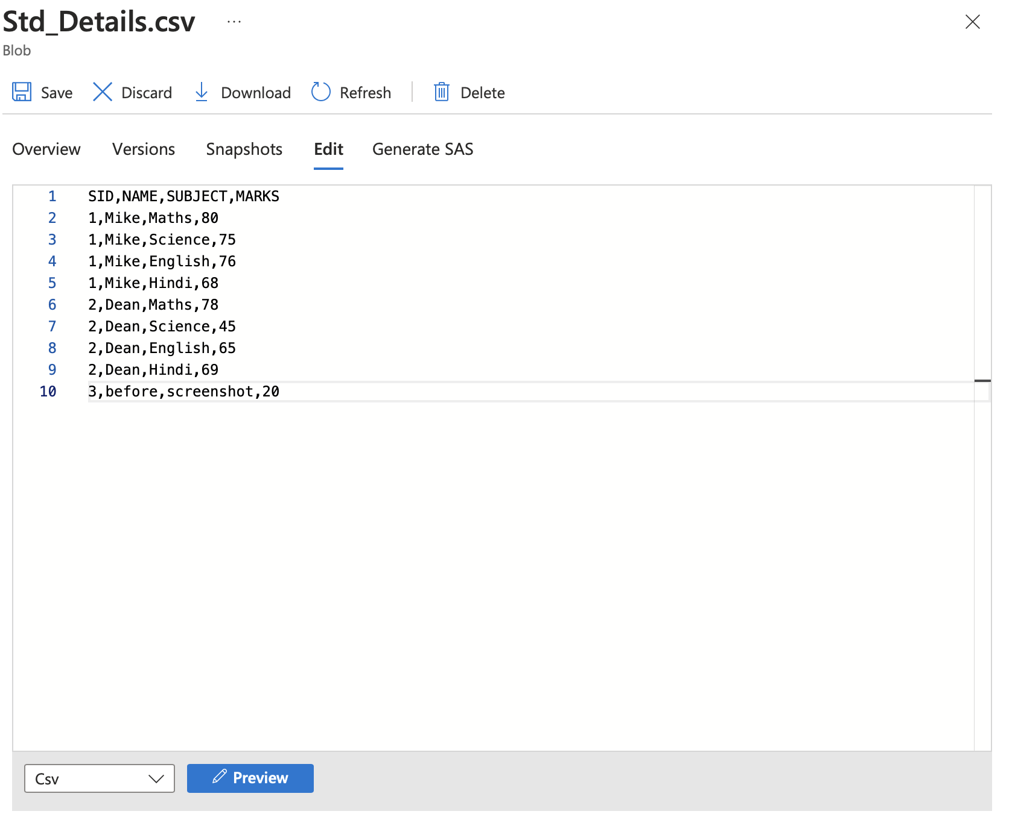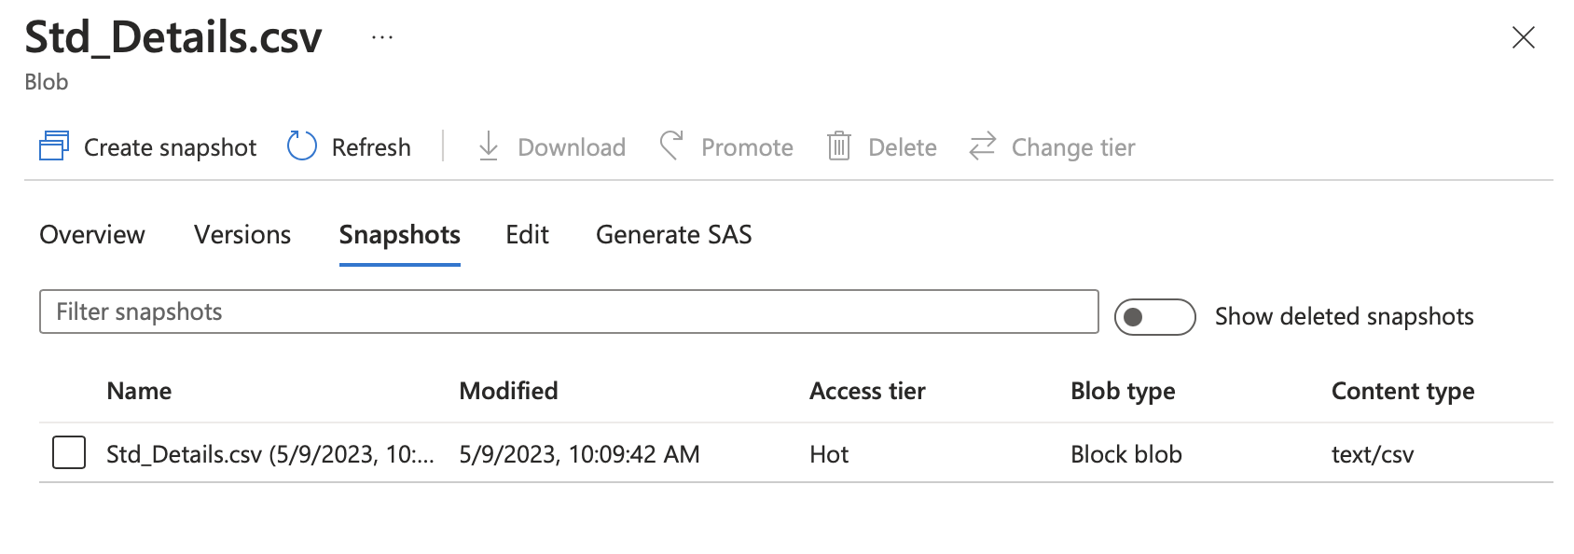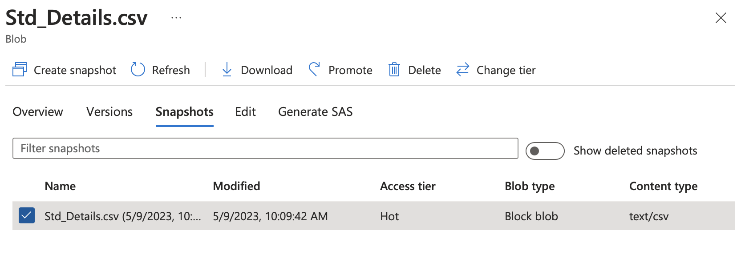

**FILE SHARES**

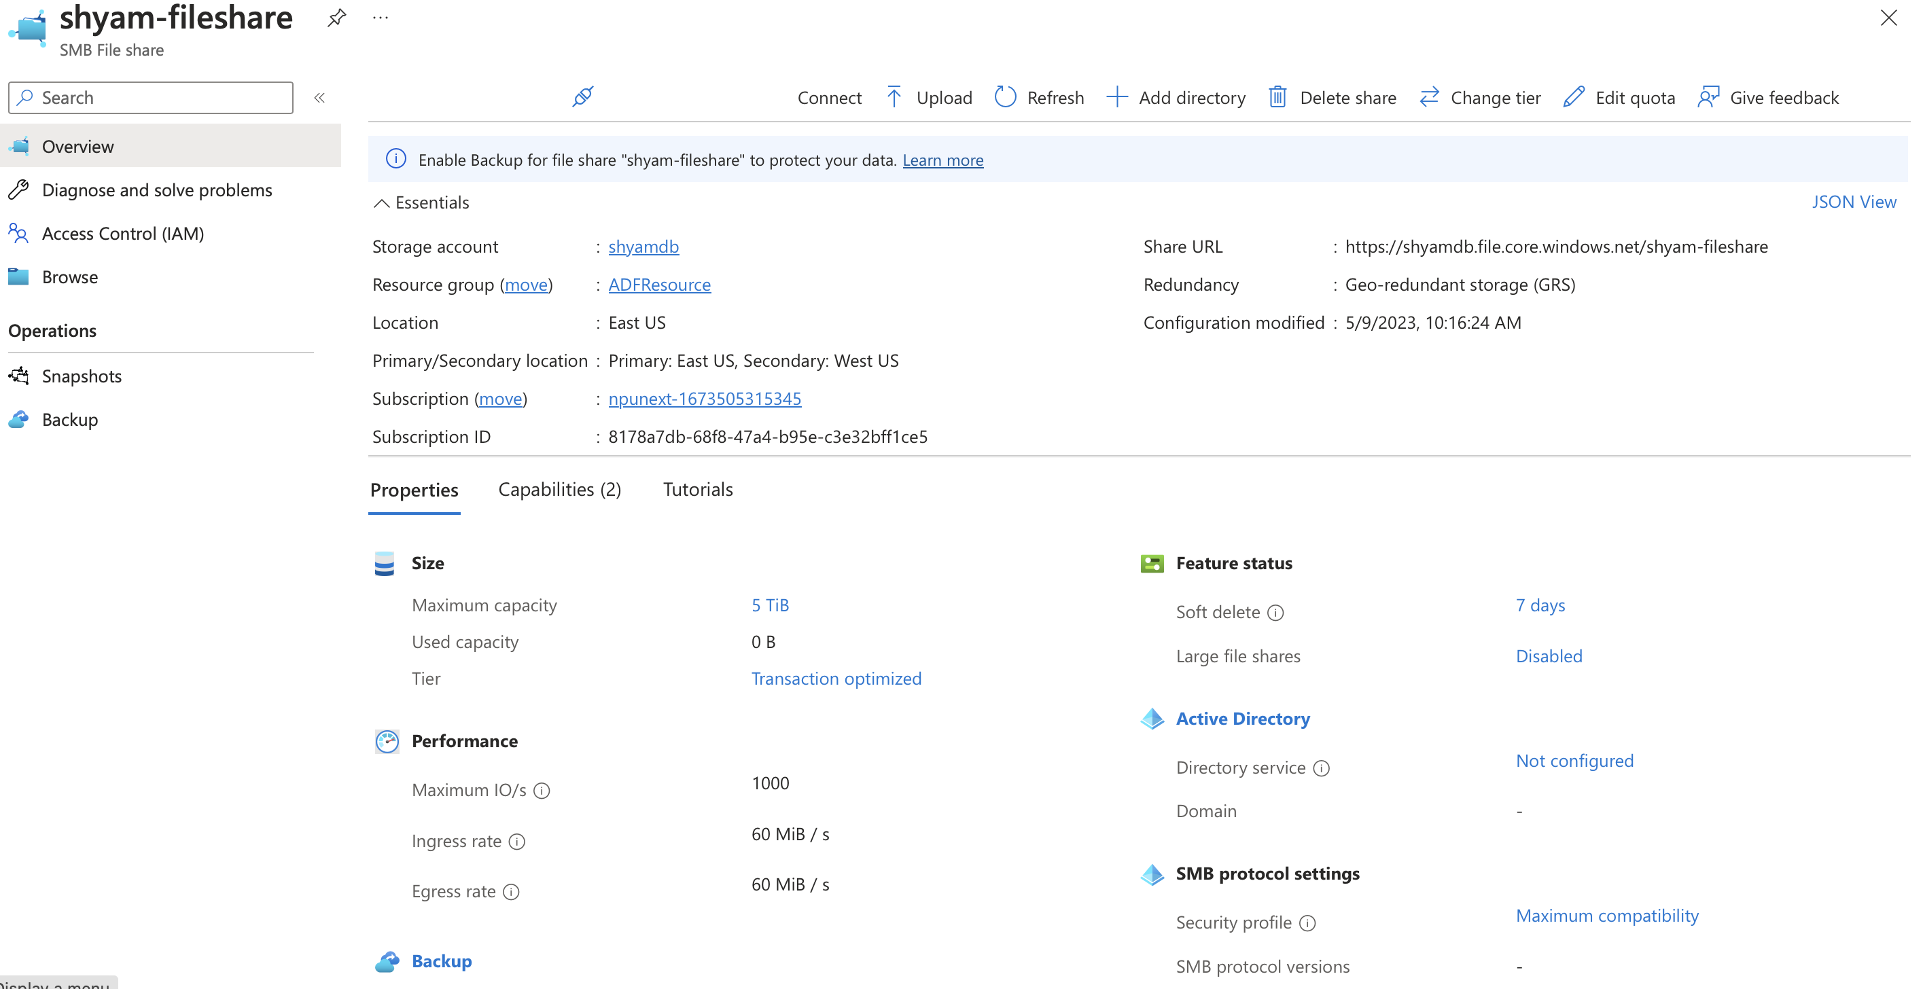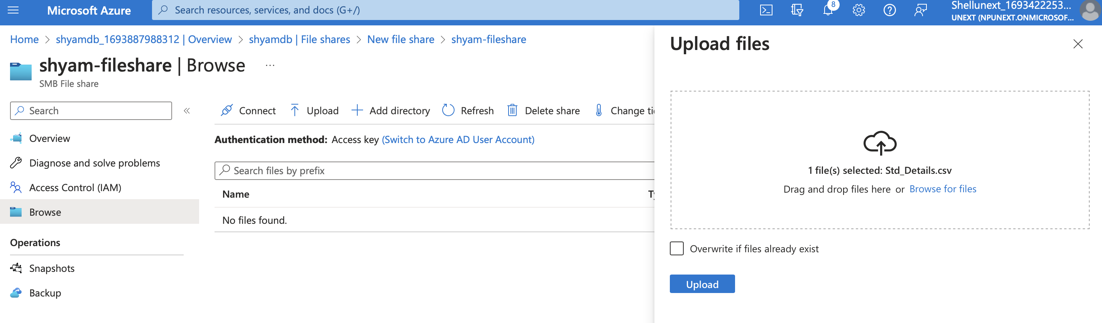

**QUEUE**

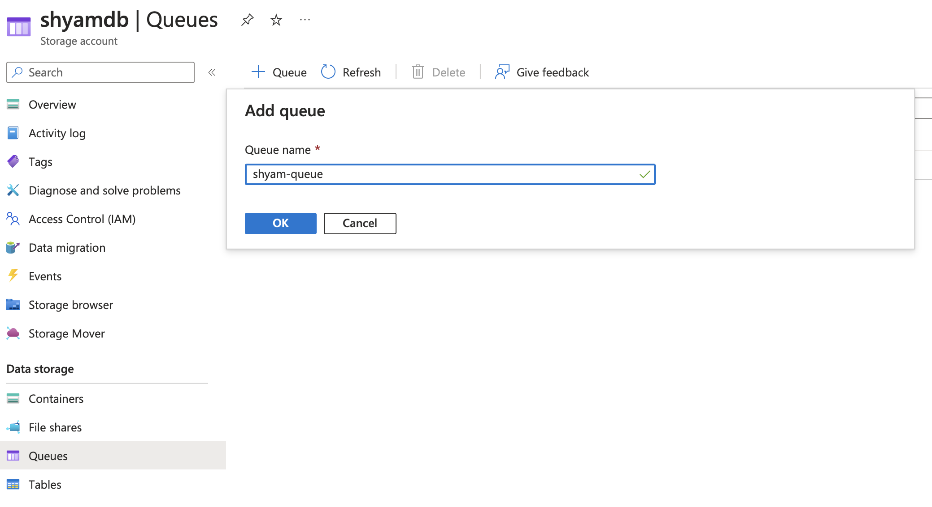

**TABLES**

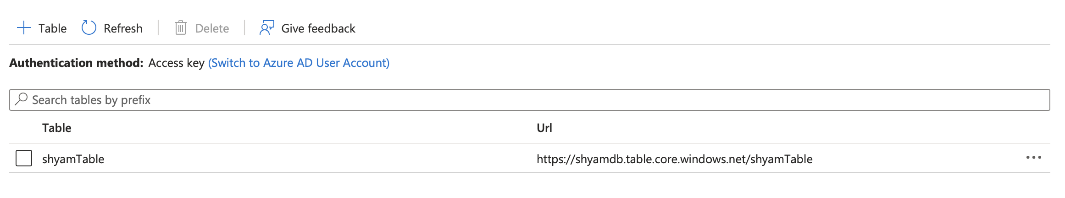

**HOT TIER**

**COOL TIER**

**ARCHIVE TIER**

**ACCESS KEYS**

**SAS (Shared Access Signature)**

